

**Assignment Of**

**Web-System & Tech (CSS Projects)**

**3 Projects**

**Submitted To:**

**Sir.Zeeshan Bhatti**

**Professor Dept:**

**Information Technology**

**Submitted By:**

**Mubashir Ali S/O**

**Mansoor Ali**

**(2k20/ITE/73) Group(A)**

**Project 1**

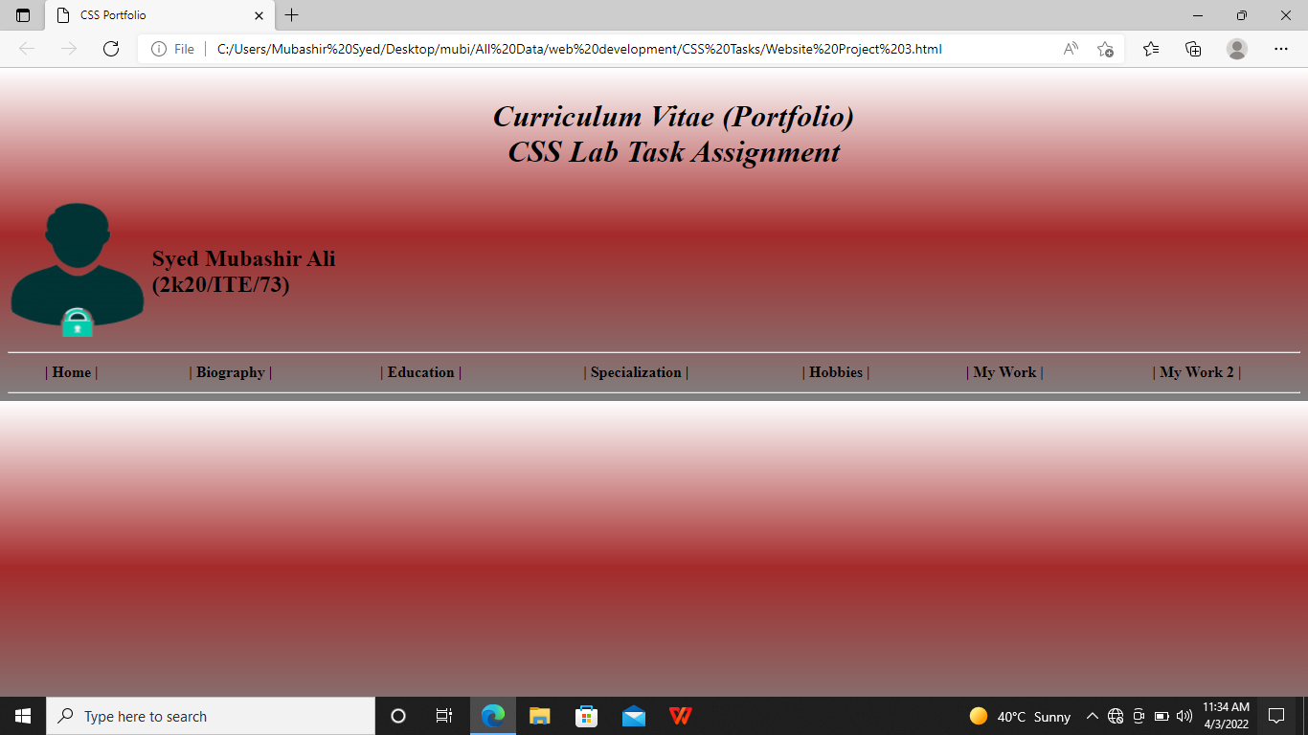

**Home Page**

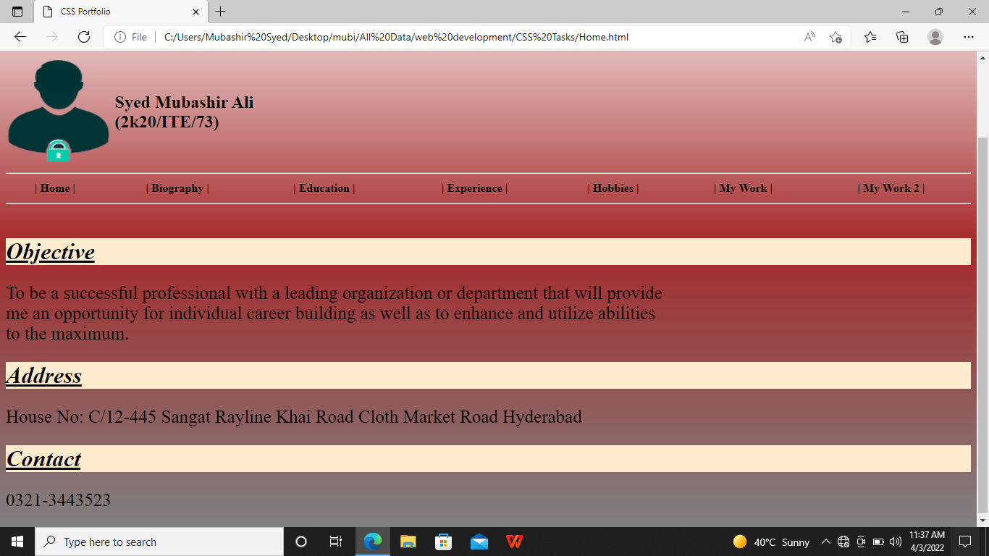

**Biography Page**

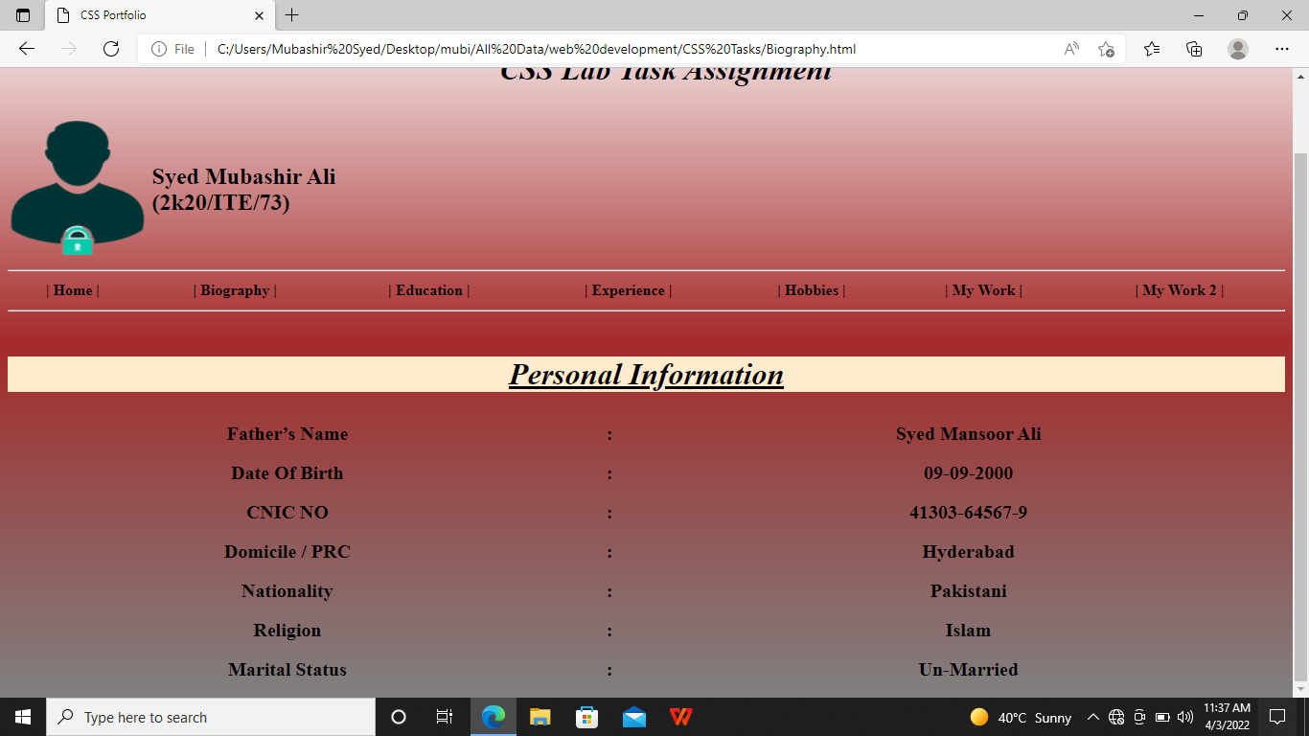

**Education Page:**

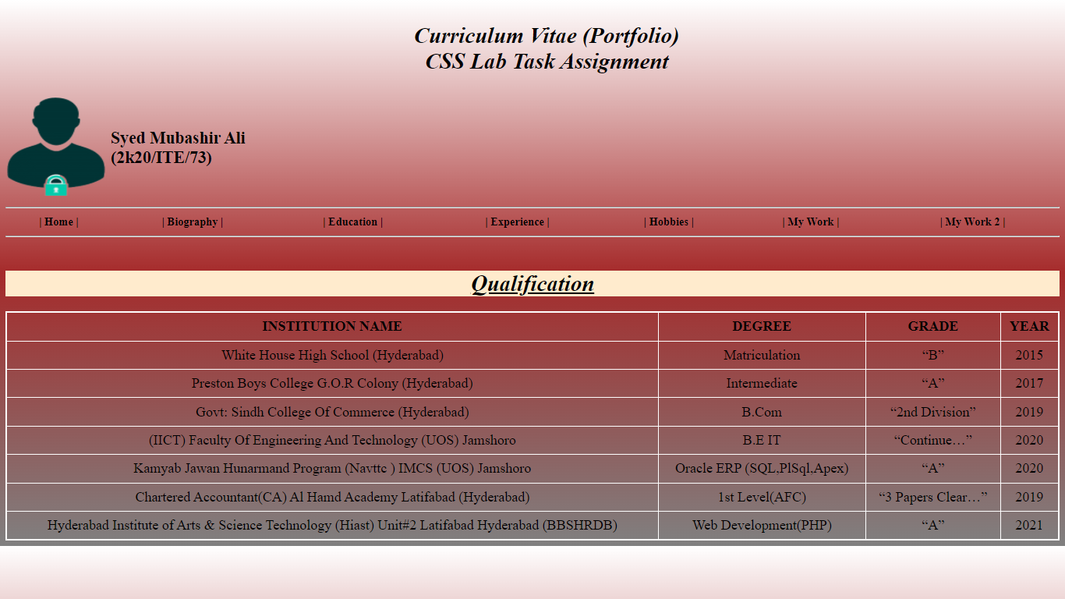

**Experience Page**

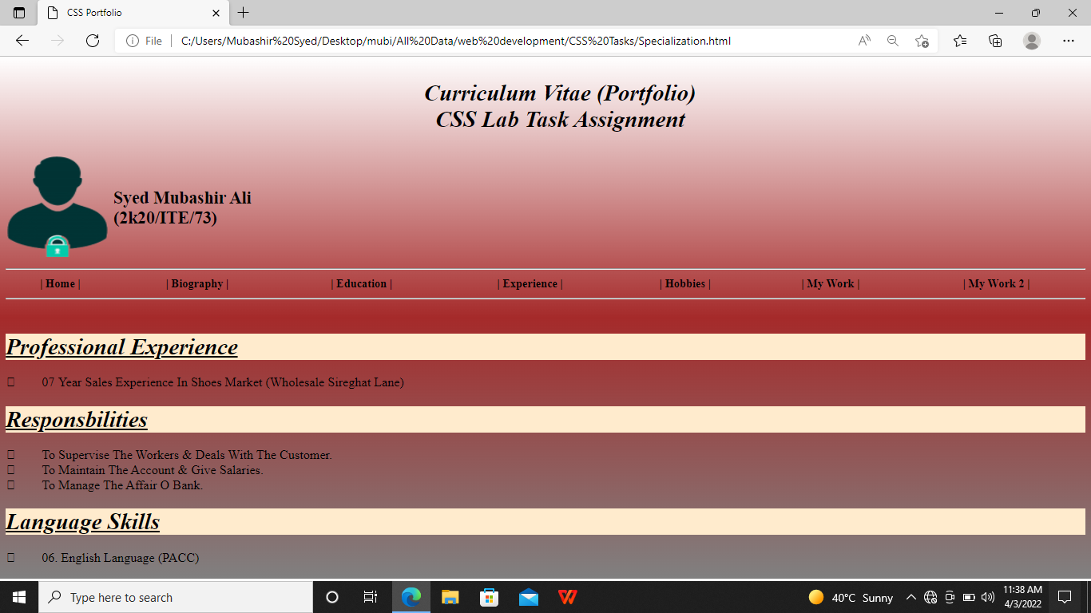

**Hobbies Page**

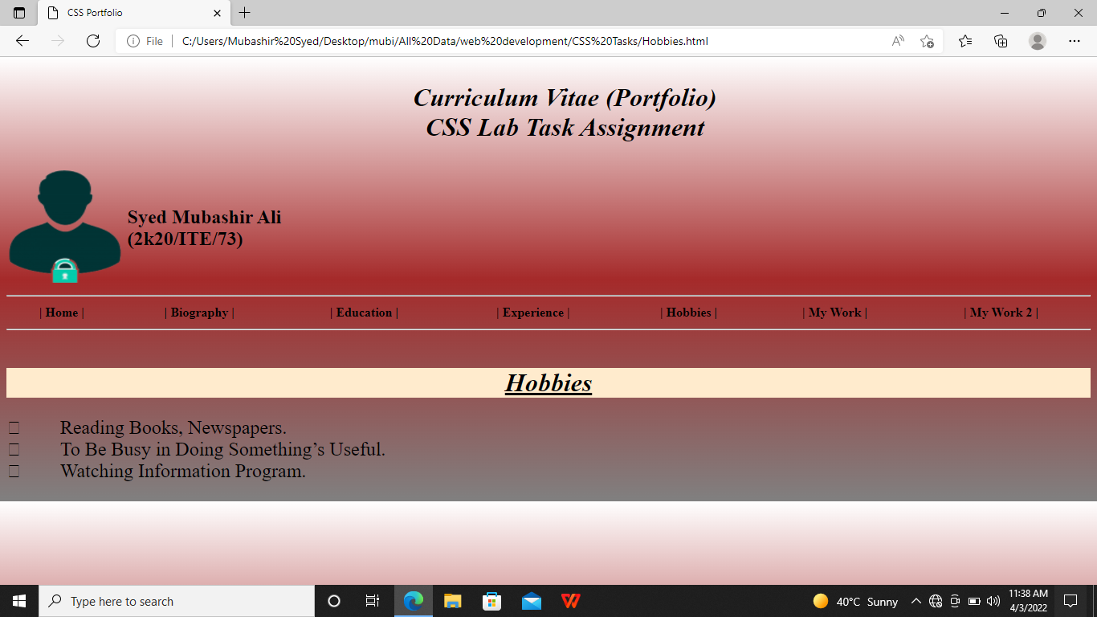

**Project:2**

**Blog Website**

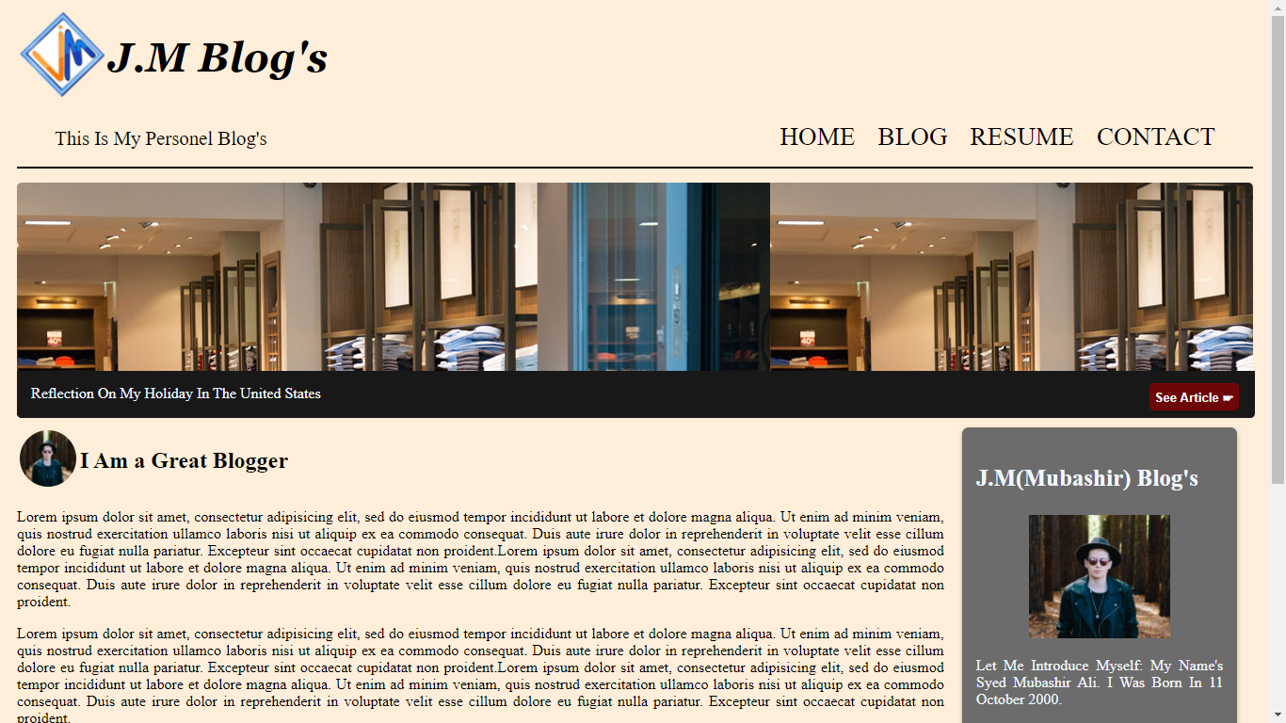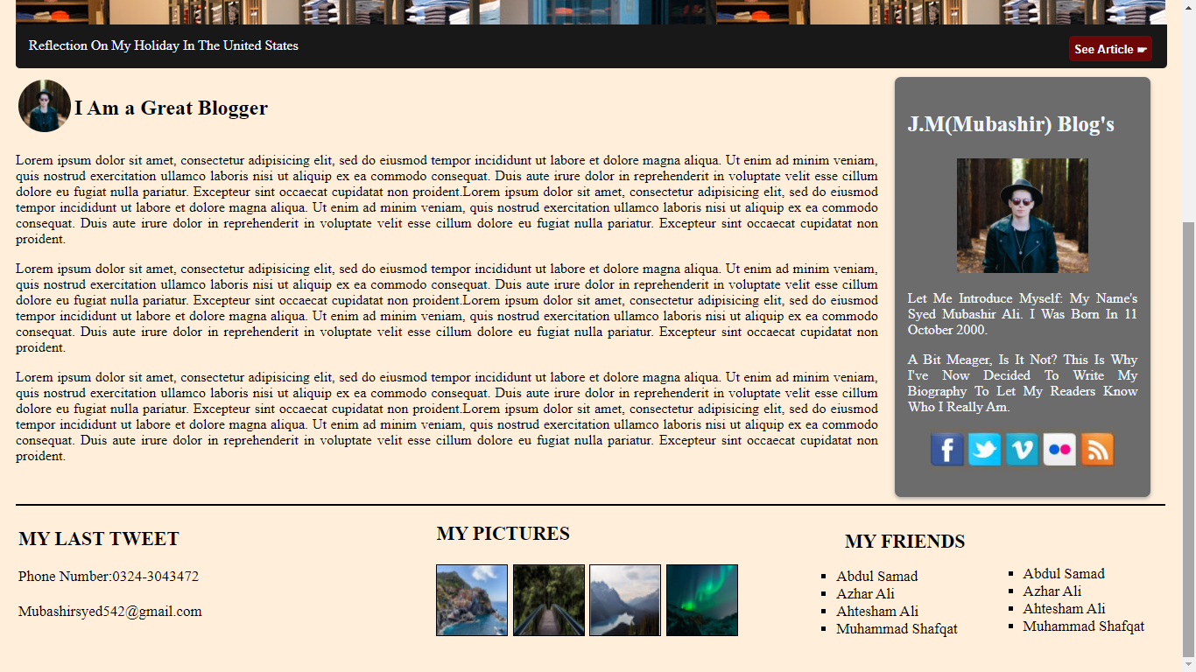

**Project:3**

**Resturant Website**

**Home Page**

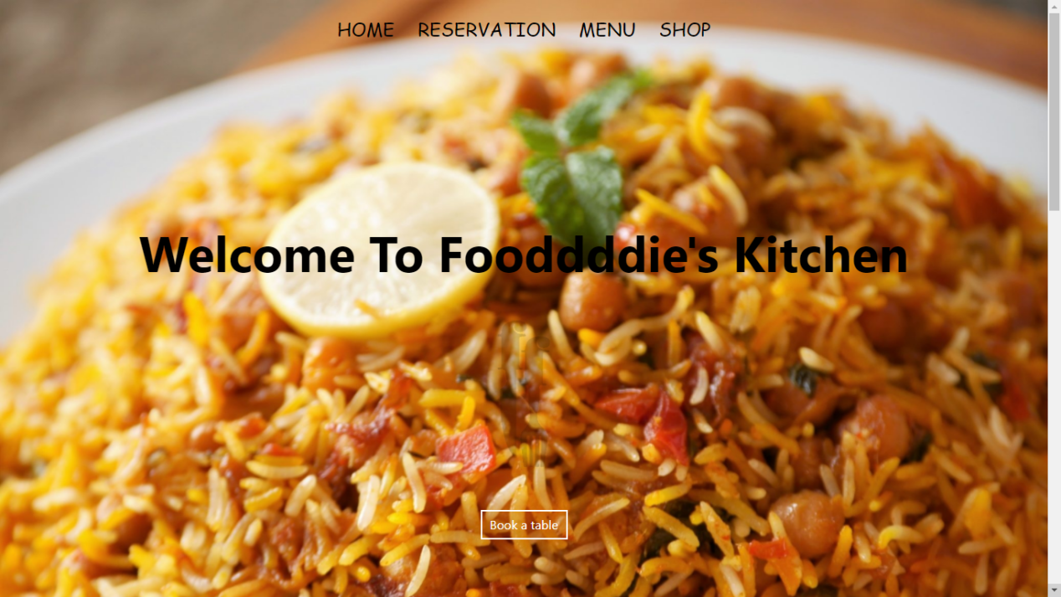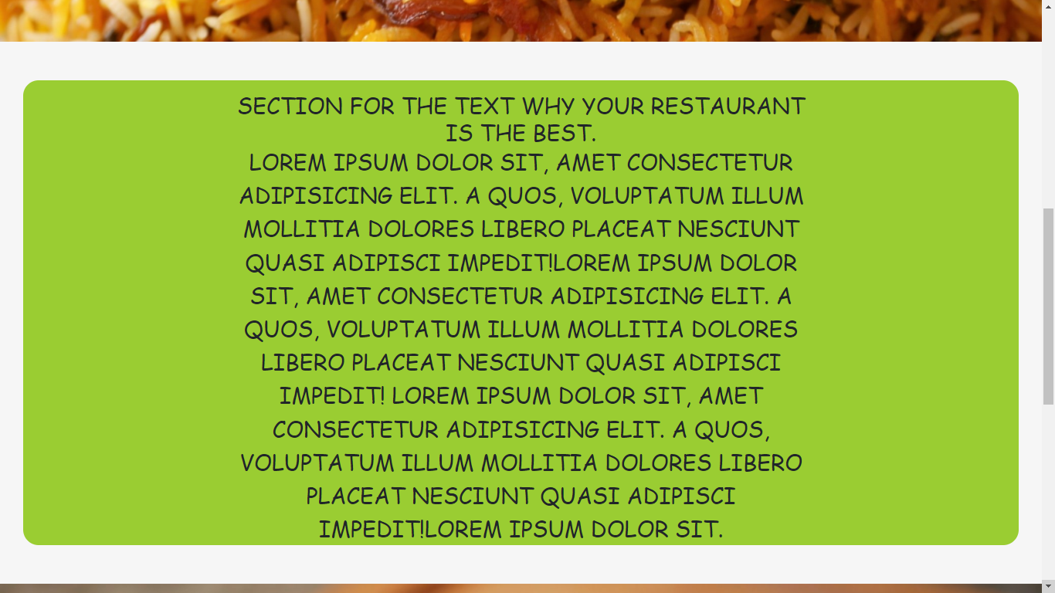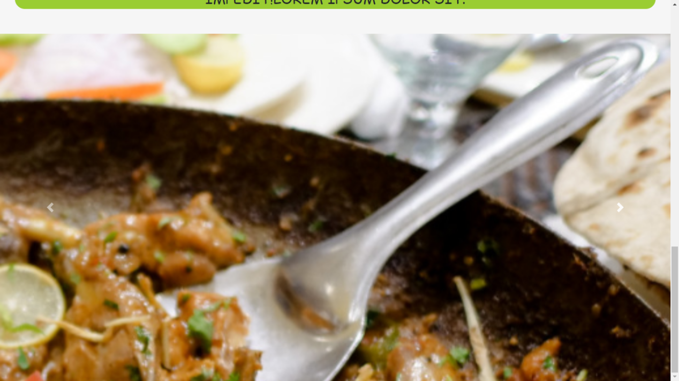

**Reservation Page:**

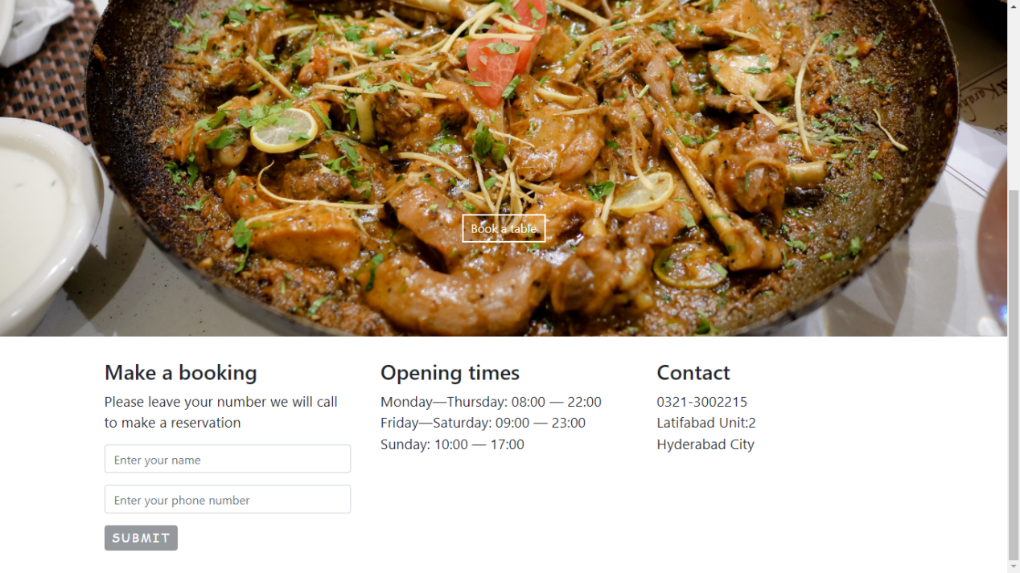

**Shop Page:**

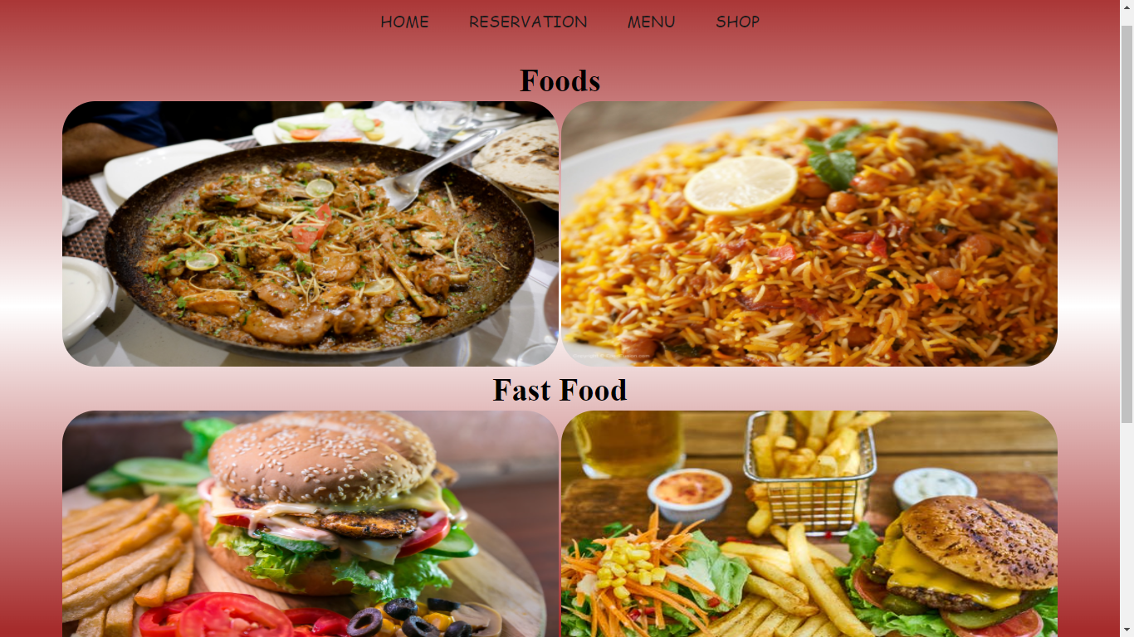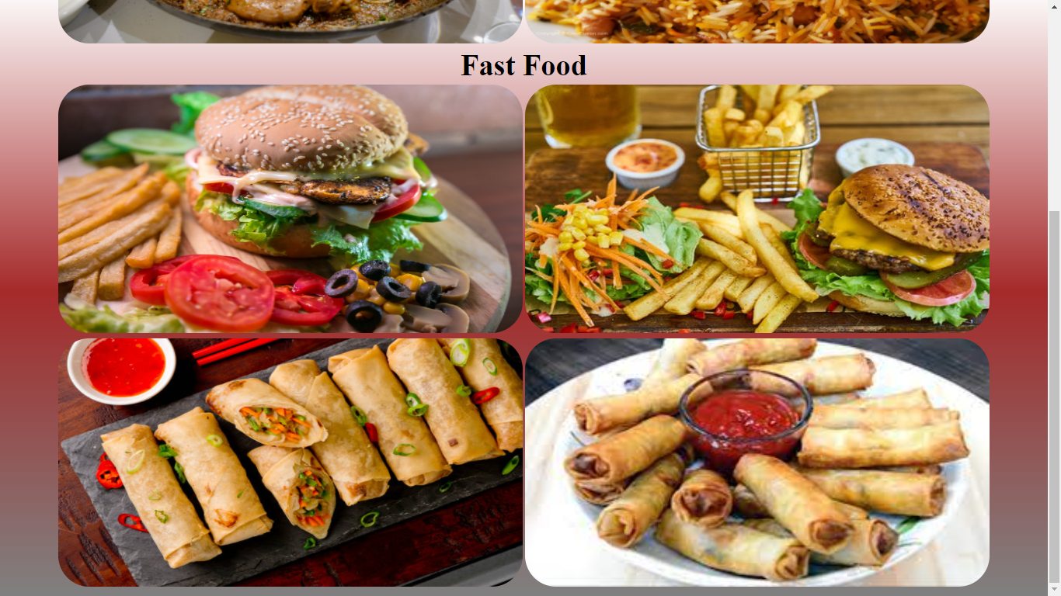

**The End**